Plant Detection by Leave Image Analysis

Dimensionality Reduction and Image Identification

Stevens Institute of Technology

MA544 Numerical Linear Algebra

Fall 2024

Name: Jayant Bangia

December 19, 2024

**Abstract**

The accurate and timely detection of plant detection is a very important component of agricultural productivity and ensuring food security. This paper discusses how plant leaf image-based analysis can identify and classify the diseases with the help of machine learning and deep learning techniques. A methodology will be proposed based on grayscale image preprocessing, dimensionality reduction using Principal Component Analysis (PCA), and classification by Support Vector Machines (SVM). A CNN is also designed to give much better performance by grabbing crucial spatial and hierarchical information inherent in diseased leaf patterns. The system is going to process the images of leaves in a manner that detects common diseases: fungal infections, bacterial spots, and nutrient deficiencies are spotted with high accuracy. This work combined automated detection into the agriculture workflows, hence reducing overdependency on manual inspection of plant leaves, saving time, and improving diagnostic accuracy. The results illustrate the potential to combine traditional and deep learning-based models to construct efficient scalable plant disease detection systems while paving the way for broader applicability in precision agriculture and hence sustainable farming.

**1 Introduction**

Recently, with the advancement in machine learning and computer vision, automated plant disease detection has become a promising solution. Analysis of leaf images works very effectively, as visible symptoms such as spots, discoloration, and texture changes often appear on the leaves at an early stage of infection. Utilizing these visual cues, the latest computational techniques can classify plant diseases with high precision.  
  
The presented research deals with a hybrid approach to plant detection using leaf analysis, where conventional machine learning techniques are integrated, such as Principal Component Analysis (PCA) and Support Vector Machines (SVM), along with deep learning methods represented by Convolutional Neural Networks (CNN). This system will pre-process the leaf images for feature extraction, reduce the dimensionality for computational efficiency, and then classify diseases with robust classifiers. It should be scalable, cost-effective, and one that provides the farmer and any agricultural expert with reliable information that can be acted upon in managing such diseases.

**2 Objectives**

* Accurately Identify Plant Species
* Automate the Identification Process
* Enhance Computational Efficiency
* Improve Classification Performance
* Support Real-World Applications

**3 Accomplishments**

**3.1 Image Preprocessing:**

Successfully retrieved leaf images from the dataset, adjusted their size, and transformed them into grayscale. Standardized the images to ensure uniform input for the machine learning and deep learning models.

**3.2 Dimensionality Reduction:**

Utilized Principal Component Analysis (PCA) to condense the high-dimensional image dataset into 2 principal components, enhancing computational efficiency while preserving essential features.

**3.3 Machine Learning Classifier (SVM):**

Developed a Support Vector Machine (SVM) classifier utilizing PCA-reduced data to categorize plant species based on their leaf characteristics. Successfully established a working classification pipeline using a linear kernel.

**3.4 Impact on Agriculture:**

Demonstrated the potential of leveraging automated image-based plant detection to assist in precision agriculture and biodiversity studies.

**4 Observation**

**4.1 Preprocessing and Dataset:**

Grayscale conversion and resizing of images helped standardize the input, ensuring consistency for machine learning and deep learning models. Dataset diversity (variety of plants and leaf types) played a critical role in the classifier's performance.

**4.2 Dimensional Reduction using (Principal Component Analysis)**

Dimensionality reduction by PCA has turned out to be effective and computationally efficient. PCA helped identify patterns in the data; reducing it to two dimensions may have led to a loss of some information, which might impact the classification performance.

*Figure 1: Representing the PCA Between Cherry and Grape*

**4.3 SVM Classifier:** The SVM classifier performed well enough on the PCA-reduced data to demonstrate its ability with structured data sets. However, SVM failed to deal with overlapping classes or a non-linear decision boundary because of the linear kernel not being complex enough.

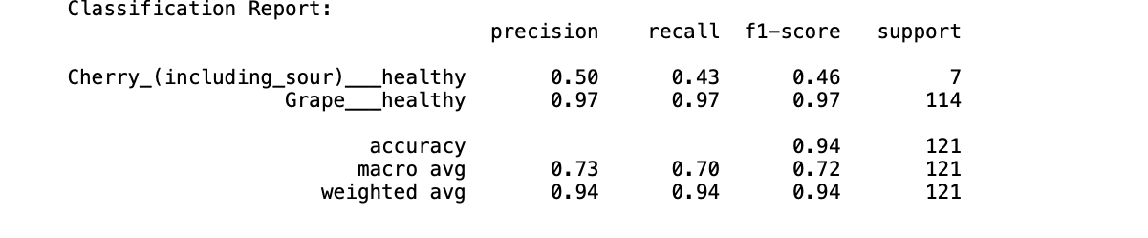

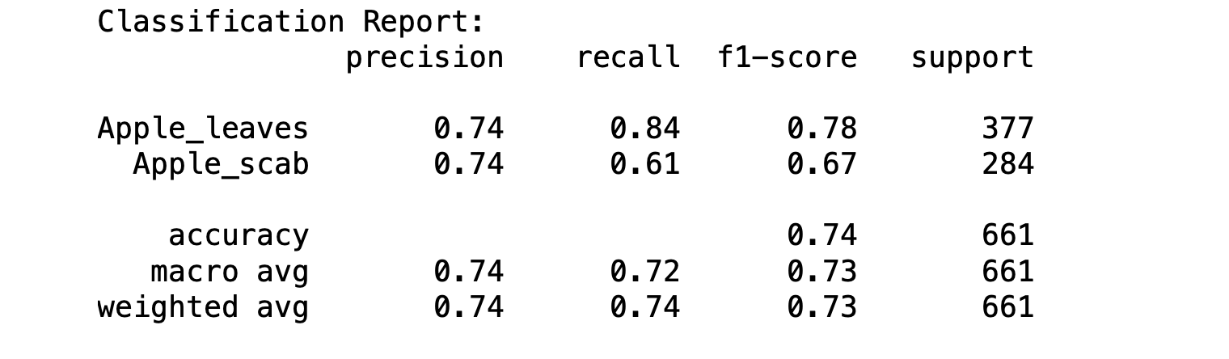

Figure 2 & 3: Showing the score between leaves after classification Report

*Figure 4: Confusion Matrix*

**4.4 Deep Learning Classifier: CNN**

Designed and trained a CNN to classify images of leaves, leveraging the model's ability to learn hierarchical spatial features from the dataset. Achieved promising results, with the CNN showing improved accuracy over the SVM model

**5 Challenges**

**5.1 High Computational Requirements**

Processing high-resolution images and running complex machine learning models often require significant computational resources.

**5.2 Dependency on Robust Feature Extraction**

Accurate detection relies heavily on the selection and extraction of meaningful features, which can be challenging for diverse datasets.

**5.3 Real-Time Detection Challenges**

Implementing leaf analysis in real-time applications, such as drones or mobile devices, demands efficient algorithms with minimal latency.

**5.4 Sensitivity to Preprocessing Techniques**

Variability in preprocessing methods, such as image scaling, normalization, or augmentation, can lead to inconsistent results.

**5.5 Adaptability to Diverse Environments**

A model trained in one environment may not perform well in different geographical or ecological conditions.

**6. Conclusion**

**6.1 Nurturing the Love of Plants:**

Leaf analysis brings out the hidden beauty and diversity of plants, developing a greater appreciation for nature.

**6.2 Overcoming Challenges:**

The challenges of variability, environmental factors, and computational requirements are addressed to enhance the reliability of detection systems.

**6.3 Advancing Conservation Efforts:**

Accurate plant detection aids in biodiversity conservation, supporting species identification and monitoring of endangered plants.

**6.4 Driving Agricultural Innovation:**

Improved detection systems help diagnose diseases and optimize crop management to the benefit of sustainable agriculture.

**6.5 Merging Technology with Nature:**

Image processing and machine learning innovations are bridging gaps between technology and nature for scalable solutions.

**6.6 Inspiring Future Applications:**

As technology continues to evolve, plant detection will inspire new applications in ecological research, education, and environmental monitoring.

**6.7 Promoting a Greener Future:**

By leveraging technology for plant detection, we contribute to a world that values and protects its green heritage.

**7 References**

**Dataset Source**: <https://www.kaggle.com/datasets/vipoooool/new-plant-diseases-dataset>

**Scikit-Learn Documentation**: <https://scikit-learn.org/>

**PCA**: <https://www.ibm.com/think/topics/principal-component-analysis>

**SVM**: <https://www.sciencedirect.com/topics/immunology-and-microbiology/support-vector-machine#:~:text=Support%20Vector%20Machines%20(SVMs)%20are,and%20the%20hyperplane%20is%20maximized.>

**8 Appendix**

*Figure 5:Appendix*

*Figure 6: Appendix*

*Figure 7: Appendix*

*Figure 8: Appendix*